**Cyber Security**



**Assignment 01**

Mir Hussain

023-19-0106

Submitted to Sir. Zakaria

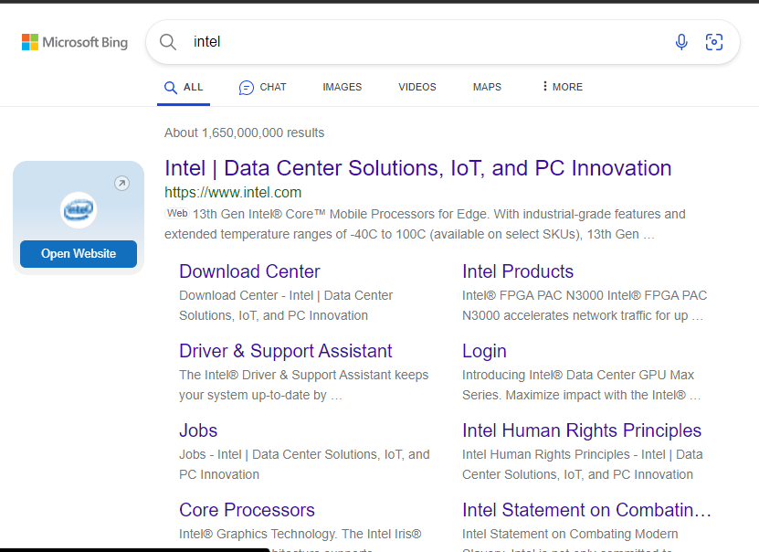

**Whois.com**

**Who.is**

**Godaddy.com**

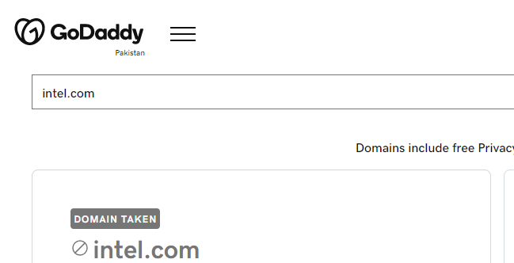

**Networking Footprinting:**

**Whatismyipaddress.com**

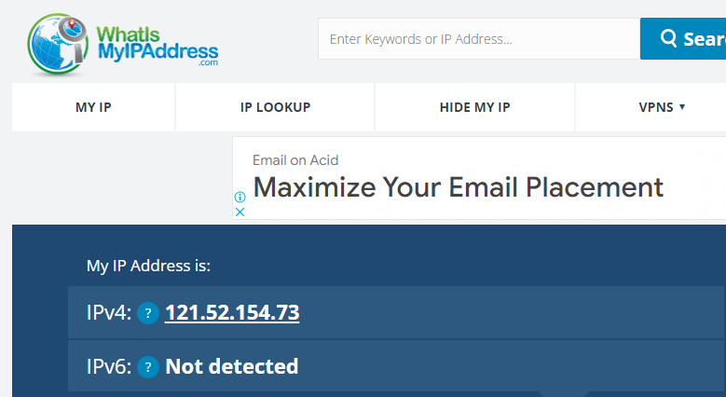

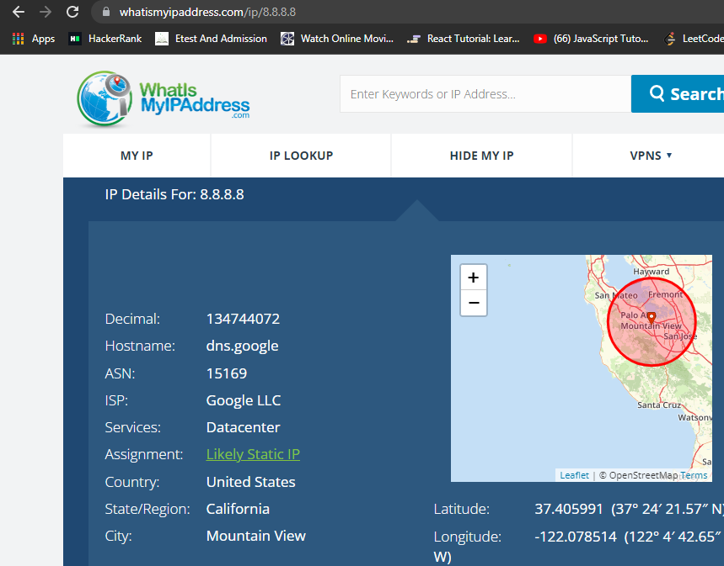

**Technicalinfo.net**

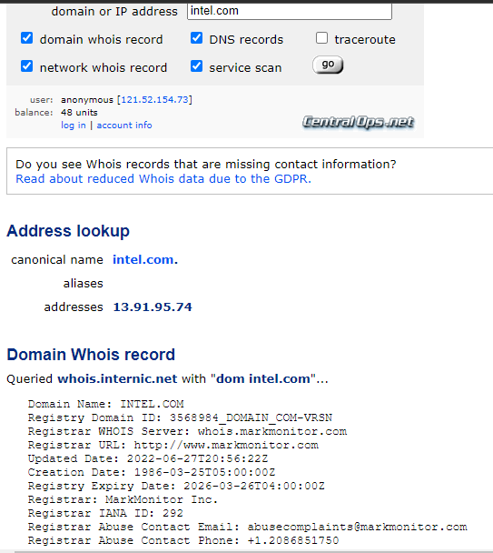

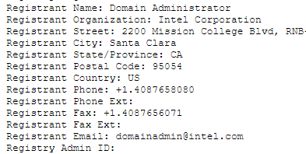

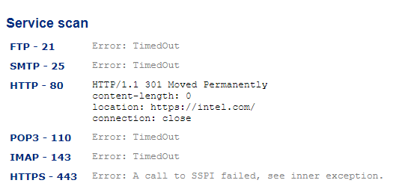

**Website:** [**www.network-tools.com**](http://www.network-tools.com)

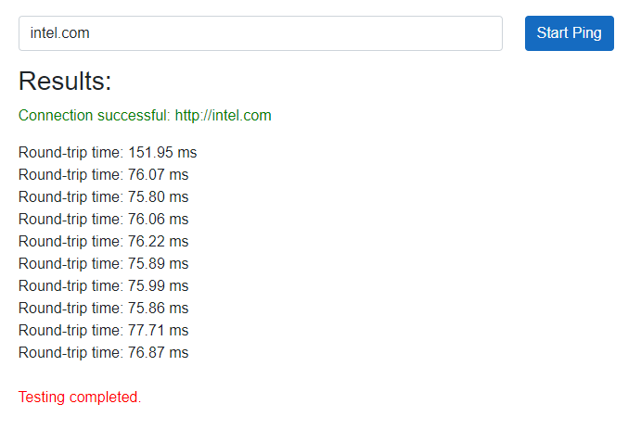

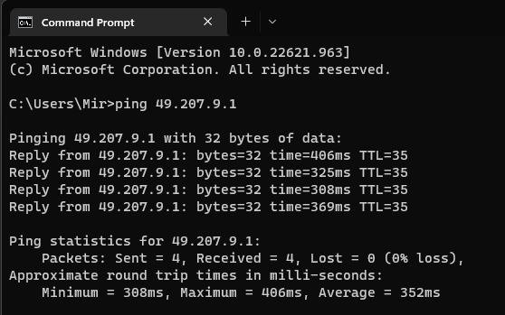

**Path analyzer pro**

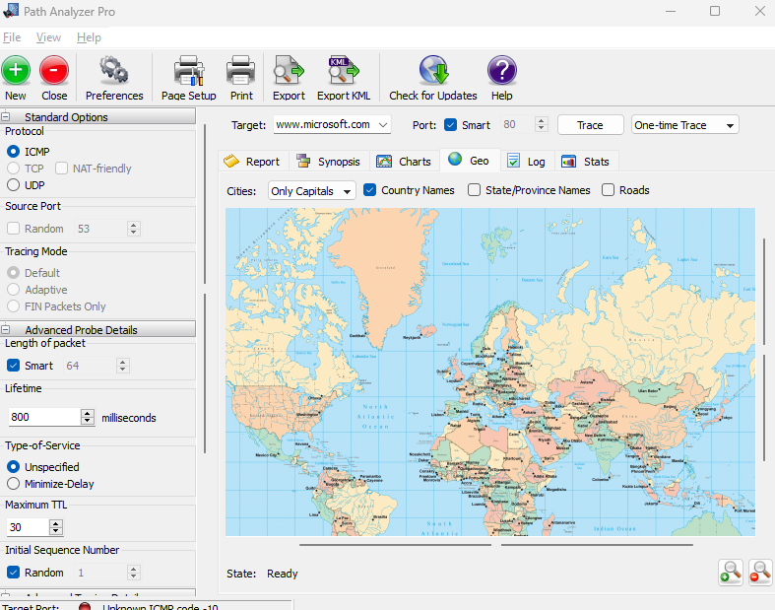

**Website: netcraft.com**

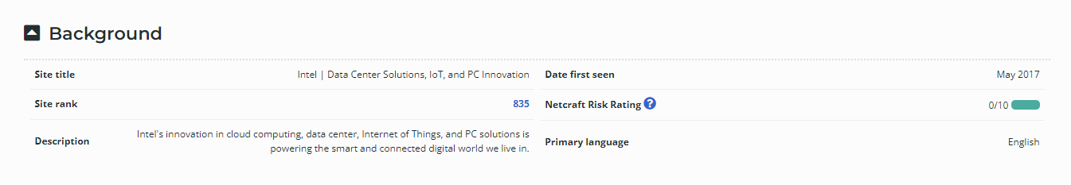

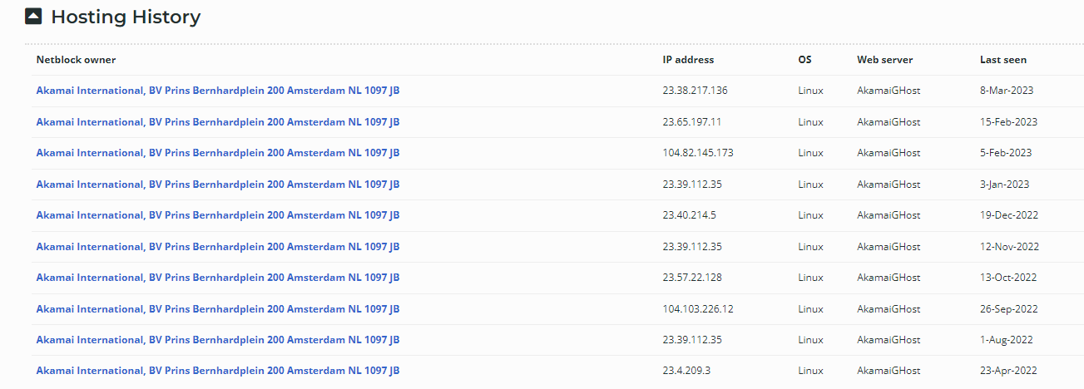

[**www.builtwith.com**](http://www.builtwith.com)

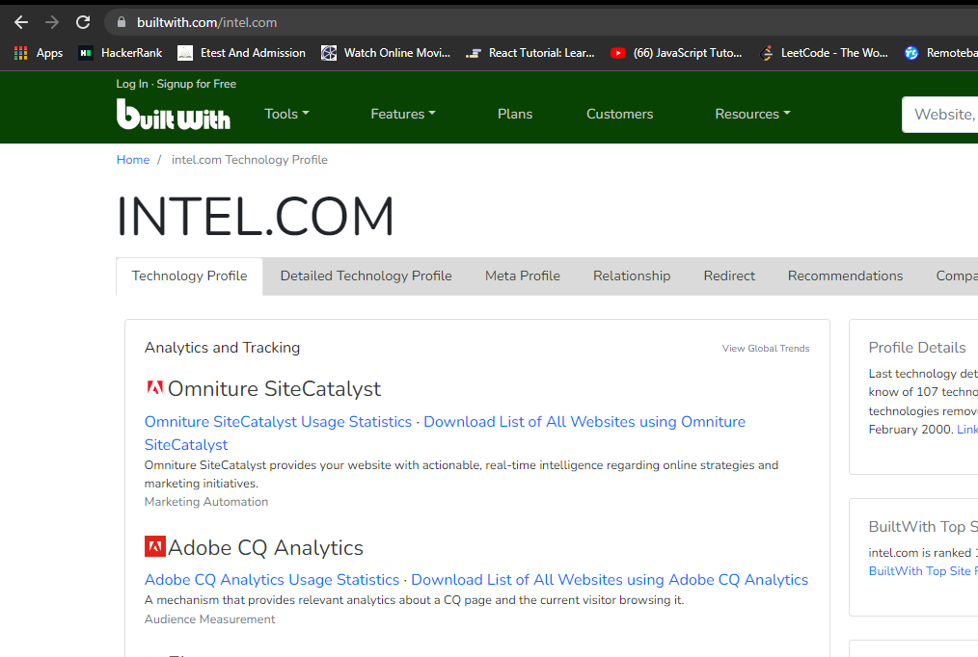

**Website:** [**www.dnsdumspter.com**](http://www.dnsdumspter.com)

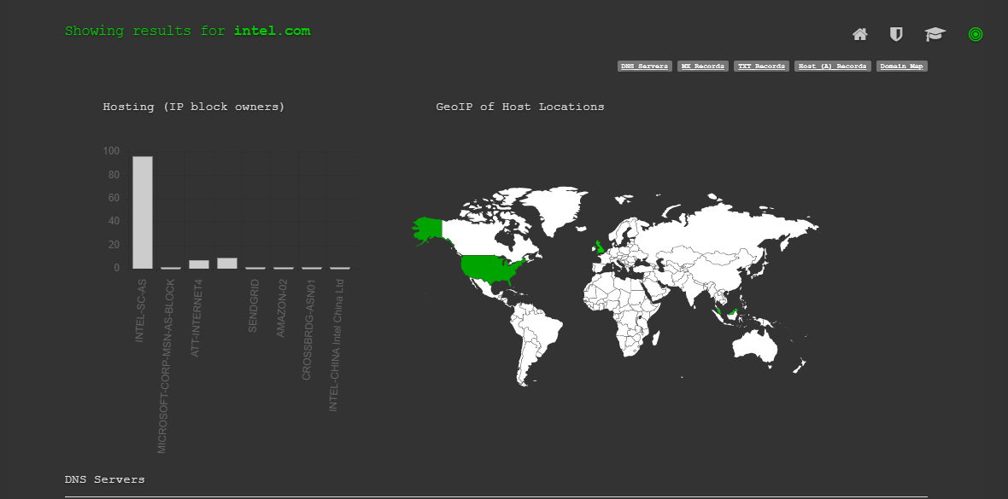

**Nslookup**

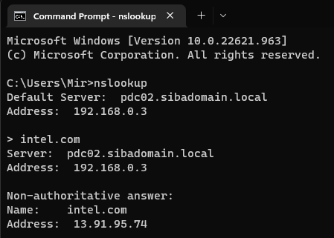

[**www.lullar.com**](http://www.lullar.com)

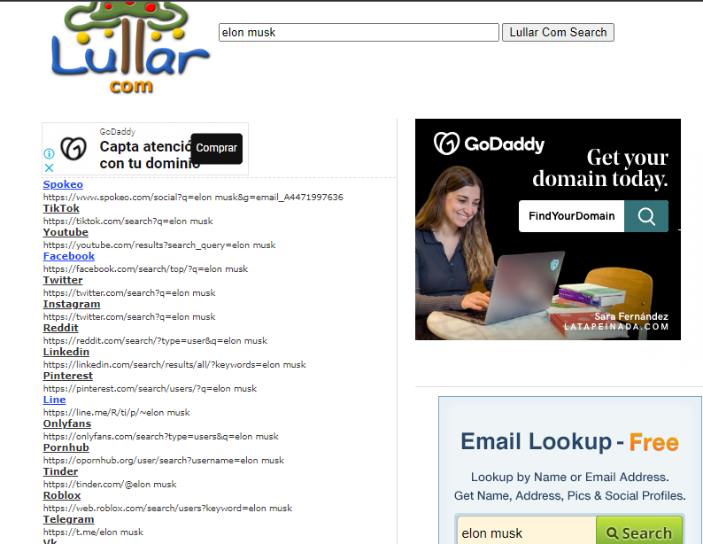

**Shodan.com**

